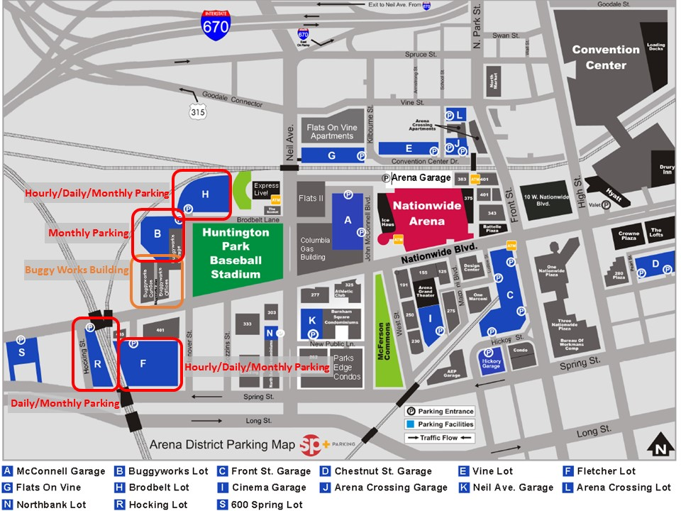

**Note:**

Accenture

400 W. Nationwide Blvd, Suite 100

Columbus, OH 43215

614.629-2411

**Front Door Metered Parking prices (Buggyworks Archway):**

* $1.50 per hour
* 2 hour max

**Included is a map of additional parking near the office.**

* Lot (H)
* Lot (B)

Pay stations are accessible and located at each outdoor parking lot. Note that parking attendants regularly monitor the lots and will issue tickets to anyone that does not have a paid parking slip or permit visible on the dashboard.

**Parking Lot prices:**

* $3.00 for 2 hours
* $5.00 for the day